HEALTH EDUCATION PROGRAMS
In Collaboration with APG Pilates &
Keep it Moving

HeartSaver CPR, First Aid and Narcan Class
Saturday September 21, 2019 1:00-6:00
APG Pilates 87 Liberty Street Newburgh
$75.00
To register: Text 914-805-8290
Email HealthEducationPrograms@gmail.com
https://www.facebook.com/HEALLC/

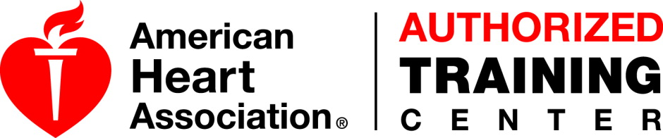

Virginia DiOrio is a Nurse, Educator, Community Activist and
Certified Instructor

